LAB 1

Summary

Switch User

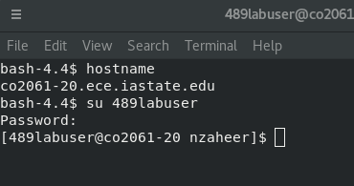
PING
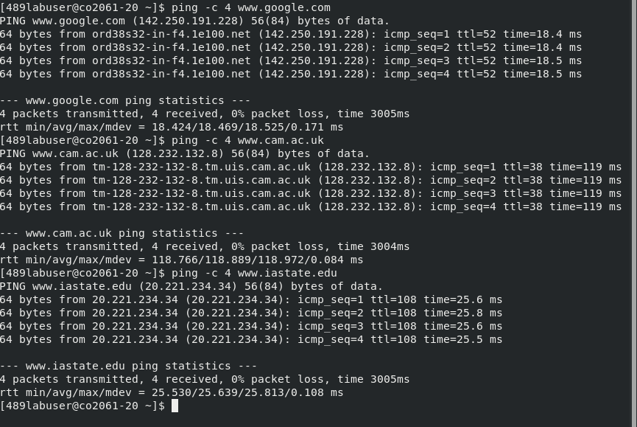
1) Average time:
Google – 18.5ms
cam.ac – 119ms
iastate - 25.6
2)
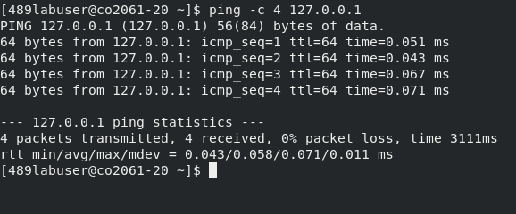
Average RTT: 0.065 ms
This is much lesser than the rest of it. The reason is pinging the localhost will return ICMP packages almost immediately since it is local to the system as compared to the other hosts which have to be accessed from a server somewhere on the internet.

nslookup

ifconfig

iperf

traceroute

tcptraceroute

Nmap

tcpdump

Wireshark

